Submitting to the NJCL Website Contest – Chapter Edition
Stephen Zhu – 2022-2023 GJCL Webmaster

Salvete, omnes! Welcome to the first edition of the “How to Submit to This Contest?” series, NJCL Website Contest edition. I know this is the first and only edition, but just go along with it . The NJCL Website Contest is a monthly-submission contest for individual JCL chapter and state JCL websites. As of now, the Georgia JCL has barely submitted to the contest, and barely any GJCL chapter has submitted as well. This guide hopes to serve as a quick summary of the submission process and a final checklist for all the required elements. As always, let me know if you have any questions, and I look forward to hearing from you all who submit to the contest.

Gratias ago vobis!
-SZ (stephen.zhu6@gmail.com)

Submitting to the NJCL Website Contest

Welcome! If you found yourself here, you are a GJCL chapter looking to submit to the NJCL Website Contest! Before you travel any further, please make sure you take a look at my guide on how to create a website, located inside 2022-2023 GJCL 1st VP Jacob Sung’s Membership handbook:
https://docs.google.com/file/d/1ivec2CFTFVivGaV0eEOGHuiW6-KgyxF0/edit?filetype=mswor
(also incredibly handy if your chapter needs an upgrade)
Also, be sure to check out the links below that goes in-depth about the NJCL Website Contest rubric, and all the suggestions I offer to get the highest scores for each submission on the website contest (more info on that below). Also, I have attached a PowerPoint (with a recording TBA) detailing tips and suggestions to add to your website once you have all the basic elements down.
Link to Rubric Analysis: https://docs.google.com/document/d/1VvfB3MOvRWd2GLYQAlYEkMCpMgyys3c3/edit
Link to Additional Tips: https://docs.google.com/presentation/d/1Mw2AhXtpzQ81tTZ0TwzGgUkuy6A5sUNK/edit#slide=id.p4
*Keep in mind that you do not need to have everything on this checklist on your website. Rather, this is a very extensive list, and even I am working on updating the GJCL website with everything on the list. However, I will be listing several key elements that you MUST have on your website for it to stand out.

STEPS TO SUBMISSION
Step 0: Check the NJCL rubric attached to this document to confirm you have all the highlighted elements on your website. Reference the attached rubric to confirm your website has all of them, along with as many additional elements as you desire. Always reference the videos: they have lots of helpful tips and informative elements.
Step 1: Navigate to the www.njcl.org website, hover over the “Students” on the taskbar, and select “Non-Convention Contests”
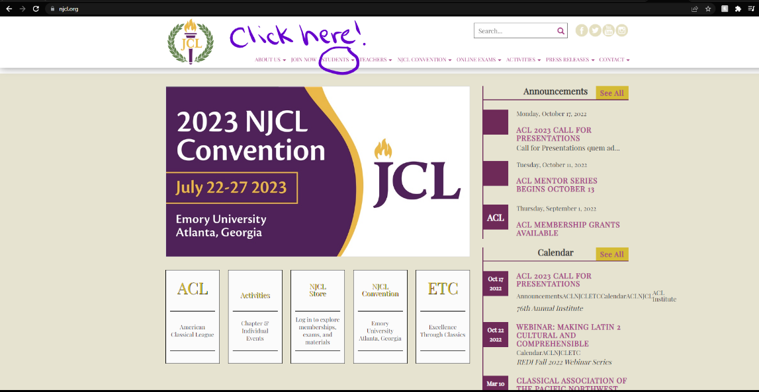
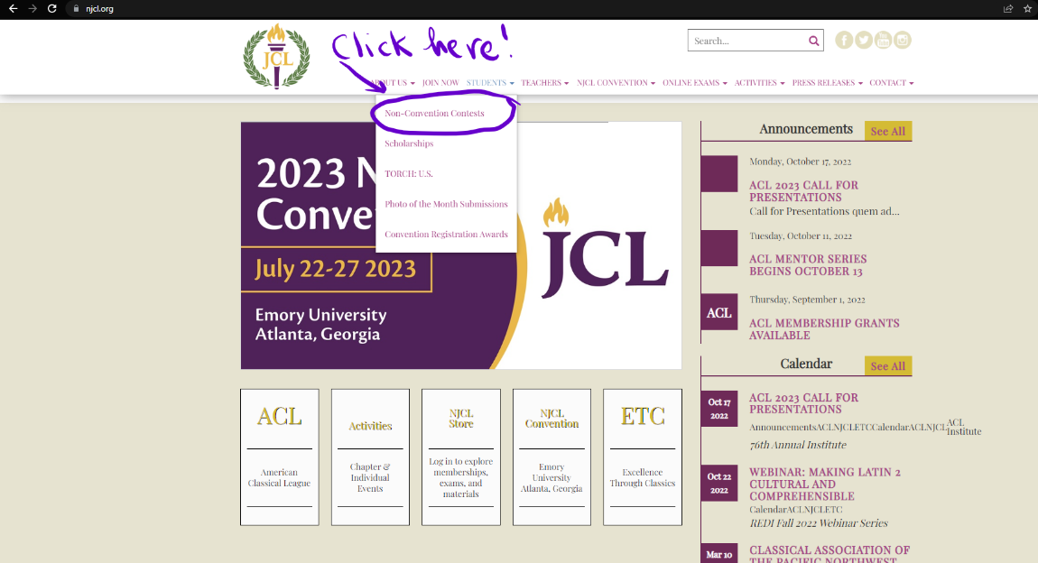
Step 2: Scroll to the bottom of the page and select “Website Contest” from the left-hand options listed.
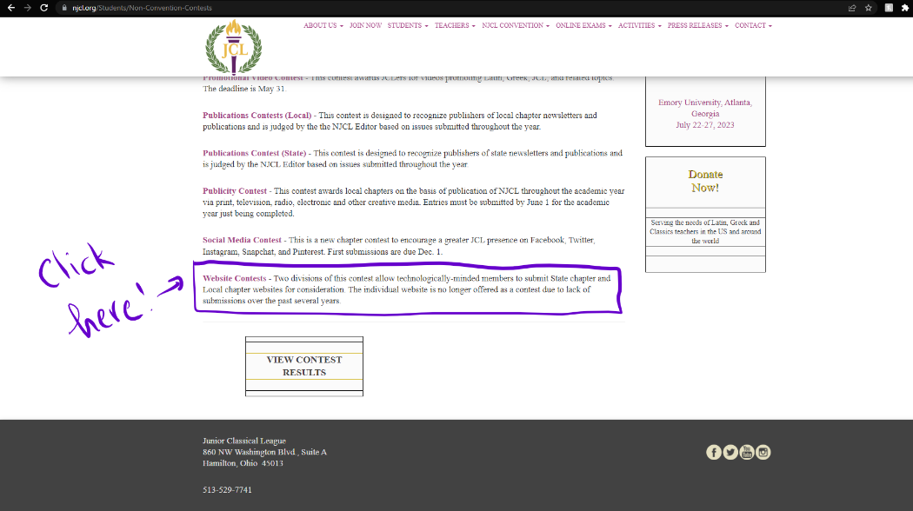

Step 3: Under the words “Click Here…”, there will be a linked phrase called “THIS FORM.” Click there. I most likely will not post the link here, as every year the link changes .
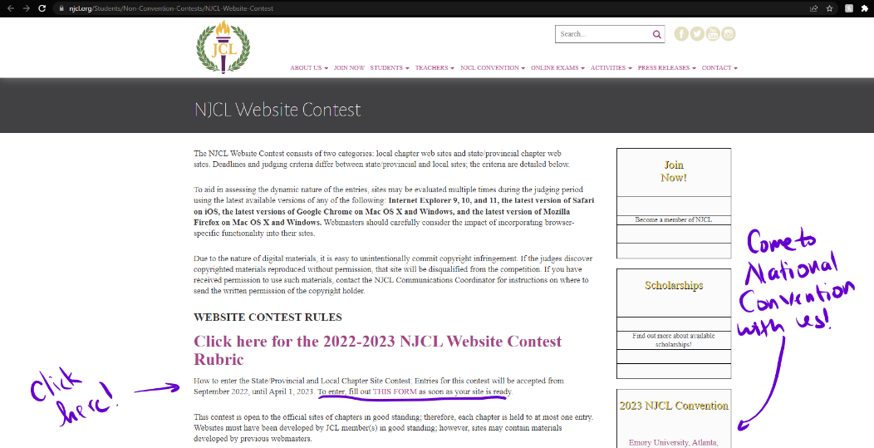

Step 4: Things get a bit complicated from here, so I will be splitting into two paths here. There are two types of submissions: 1) New Submissions, and 2) Returning Submissions

New Submissions:
- Select “First Submission” on the first page
- Fill out everything else on the second page. Select “Local” at the bottom. Our GJCL state chair is Mrs. Rachel Ash, and her email is deabelli@gmail.com
- Fill out then your city and state of your school (not where you, the Webmaster/designated affiliate, are from), chapter name (Walton JCL, Northview JCL, etc.), the URL of your website, and your digital signature.
- Congratulations! You have submitted your website to the NJCL Contest! Now wait another year or so and fill out the form again for currency points (discussed in the video)!

Returning Submissions:
- *Note: this submission is entirely OPTIONAL: if you did not make any meaningful contributions to your website (which I highly doubt) or just do not feel like submitting, it is perfectly fine. No points will be deduced for not submitting.
- Select “Returning Submission” on the first page
- Fill everything else out on the forms that follow as instructed.
- *Very important: to maximize the currency points, you should have the following in the “Please thoroughly describe all changes made to your website since last month” section:
  - Explain in good detail the changes on your website. This aspect is not about adding as many changes per month as possible! Quantity is not always better.
  - Include the following: 1) the description of your change on the website, 2) any background or context for the event/change (optional for the event), 3) reasoning for this change (optional), and 4) a link to the change itself on your website.
  - Example description that could work: One addition I made to [__] website was updating our calendar of upcoming events. I took down the recently completed events such as [__] and [__] and replaced them with our next upcoming events [_], [__], and [___]. I also added captions for each new event; for example, [_____] (description). Link: ____

You did it! You submitted your website to the NJCL Website Contest and maybe completed the Returning Submission forms. I know this guide was very long, but I hope you found this helpful in maximizing points for your submission. Let me (or the current Webmaster) know if you have any questions about the links, submissions, or the guides themselves.

Signing off for now, et ave atque vale!

Stephen Zhu

