2023 GJCL Ancient Geography Exam
1. The city of Jerusalem was known to the Romans at one point as
a. Aelia Capitolina b. Sidon c. Caesarea d. Machareus
2. In which province was the city of Cordoba located?
a. Baetica b. Lusitania c. Cappadocia d. Dalmatia
3. In traveling from Rome to Tarentum, what direction would one venture?
a. northeast b. southwest c. northwest d. southeast
4. If Aeneas had decided to sail from Carthage to Knossos, which direction would he travel?
a. West b. South c. North d. East
5. The Roman province of Dacia is roughly equivalent to the geography of which Eastern European nation?
a. Bulgaria b. Romania c. Serbia d. Poland
6. Which of these cities is NOT located in ancient Greece:
a. Mycenae b. Sardis c. Orchomenus d. Corinth
7. Which province did not border on Tarraconensis?
a. Lusitania b. Aquitania c. Baetica d. Lugdunensis
8. The modern Greek island of Corfu was known as ____ in classical times
a. Cephallenia b. Zacynthus c. Leucas d. Corcyra
9. The ancient town of Lutetia is now
a. London b. Paris c. Coln d. Lyon
10. Which Italian city is to the south of Rome?
a. Tarentum b. Tarquinii c. Asculum d. Mutina
11. All of the following are Latin names for the Mediterranean Sea except which?
a. Mare Hyrcanum b. Mare Nostrum c. Mare Internum d. Mare Mediterraneum
12. All of the following cities are south of Mt. Olympus except:
a. Pydna b. Eleusis c. Sparta d. Naupactus
13. Into what two provinces was Mauretania divided?
a. Numidia & Cyrenaica b. Armenia & Cappadocia c. Tingitana & Caesarensis d. Citerior & Ulterior
14. Which city in Sicily is farthest west?
a. Syracuse b. Eryx c. Agrigentum d. Lilybaeum
15. Which sequence is correct in the Roman Forum from West to East:
a. Arch of Septimius Severus, Regia, Curia
b. Curia, Temple of Antoninus & Faustina, Arch of Titus
c. Temple of Vesta, Temple of Antoninus & Faustina, Curia
d. Imperial Rostra, Regia, Arch of Septimius Severus
16. Which of the provinces in Greece, divided by Trajan, contained the famous cities of Athens, Sparta and Corinth?
a. Epirus b. Macedonia c. Achaea d. Laconia
17. Ephesus, where the famous temple of Artemis was located, is situated on which river?
a. Cayster b. Meander c. Hermus d. Granicus
18. Which modern place did the Romans call Caledonia?
a. Ireland b. Austria c. Scotland d. Belgium
19. Which of these cities is located in Italy?
a. Phaistos b. Rhegium c. Messana d. Mytilene
20. Which city was in Etruria?
a. Rhegium b. Tarquinii c. Syaracuse d. Neapolis
21. Mt. Eryx was located in the province of _________.
a. Sicilia b. Corsica c. Sardinia d. Dacia
22. The Italian town of Padua was known as ______________ to the Romans.
a. Padus b. Patavium c. Panormus d. Pisae
23. The city of Salonae, modern Split in Croatia, was located in ancient _________.
a. Dalmatia b. Moesia c. Pannonia d. Raetia
24. The Arch of Titus commemorates the emperor’s capture of Jerusalem, known then to the Romans as
a. Gerasa b. Galicia c. Heliopolis d. Hierosolymna
25. Sarmizigethusa was the capital of _________.
a. Sicilia b. Corsica c. Sardinia d. Dacia
26. The Roman name for modern-day Budapest:
a. Aquincum b. Vindobona c. Singidunum d. Salonae
27. Which of the following Roman provinces was NOT located in Gallia?
a. Comata b. Aquitania c. Achaia d. Lugdunensis
28. The town near the famous palace of Hadrian is now called Tivoli, in ancent times it was?
a. Tibur b. Collatia c. Treba d. Tusculum
29. Which city is correctly paired with its earlier Greek name?
a. Carthago Nova/Massilia b. Brundisium/Neptunia c. Istanbul/Byzantium d. Narbo/Neopolis
30. The ancient Roman name for the Spanish port of Cadiz is
a. Arretrium b. Gades c. Carthago Nova d. Cartagena

MAP 1 – use this map to answer questions 31-40
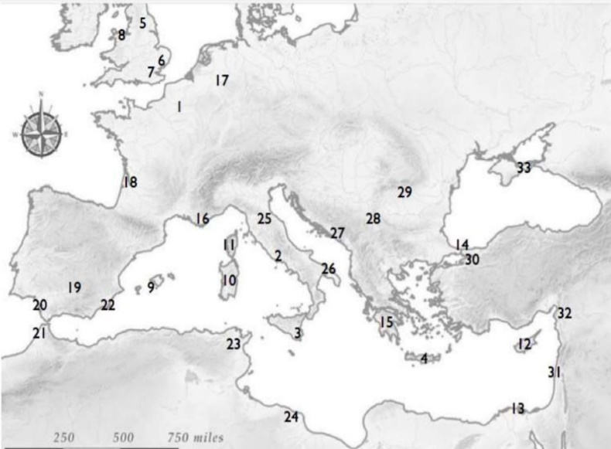
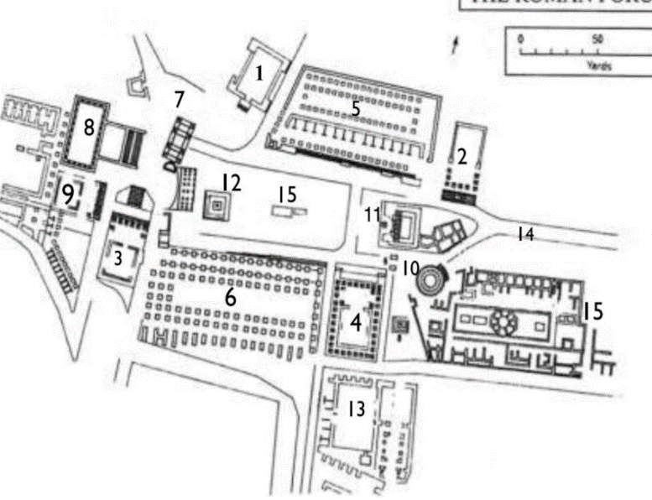

31. Which of the buildings is the Temple of Vesta
a. 9 b. 10 c. 11 d. 12
32. Which of the buildings is the Basilica Aemilla
a. 2 b. 3 c. 4 d. 5
33. Which of the buildings is the Temple of Saturn?
a. 3 b. 4. c. 5 d. 6
34. Which of the buildings is the Curita?
a. 1 b. 2 c. 3 d. 4
35. Which of the buildings is the Umbilicus?
a. 5 b. 6 c. 7 d. 8
36. Which building is the Temple of Castor and Pollux?
a. 3 b. 4 c. 5 d. 6
37. Which of the buildings is the Basilica Julia?
a. 3 b. 4 c. 5 d. 6
38. Which of the buildings is the record office?
a. 9 b. 10 c. 11 d. 12
39. Which of the buildings is the Temple of Caesar?
a. 10 b. 11 c. 12 d. 13
40. Which of the buildings is the Lacua Curtius?
a. 12 b. 13 c. 14 d. 15

MAP 2 – Use this map to answer questions 41-50

41. Which number represents the location of Brundisium?
a. 26 b. 29 c. 20 d. 12
42. Which number represents the location of Cyprus?
a. 26 b. 29 c. 20 d. 12
43. Which number represents the Pillars of Hercules?
a. 26 b. 29 c. 20 d. 12
44. Which number represents the location of Crete?
a. 3 b. 22 c. 13 d. 4
45. Which number represents the location of Chersonnesos?
a. 5 b. 33 c. 14 d. 25
46. Which number represents the location of the Hellespont?
a. 5 b. 33 c. 14 d. 25
47. Which number represents the location of Alexandria?
a. 3 b. 22 c. 13 d. 4
48. Which number represents the location of Dacia?
a. 21 b. 29 c. 30 d. 9
49. Which number represents Carthago Novo?
a. 3 b. 22 c. 13 d. 4
50. Which number represents the location of Sicily
a. 3 b. 22 c. 13 d. 4

ANCIENT GEOGRAPHY KEY

1 a
2 a
3 d
4 d
5 b
6 b
7 d
8 d
9 b
10 a
11 a
12 a
13 c
14 c
15 b
16 c
17 a
18 c
19 c
20 b
21 a
22 b
23 a
24 d
25 d
26 a
27 c
28 a
29 c
30 b
31 b
32 d
33 a
34 a
35 c
36 b
37 d
38 a
39 b
40 d
41 a
42 d
43 c
44 d
45 b
46 c
47 c
48 b
49 b
50 a

